

**OCCUPATION ADVERTISING SYSTEM**

**FINAL REPORT**





**DECLARATION**

We hereby declare that the project work in making the Software Engineering & Project submitted to the Sri Lanka Technological Campus is a record of an original work done by us, under the guidance of our supervisor.

Information derived from the published or unpublished work of others has been acknowledged in the text**.**

**Project Title** : - Occupation Advertising System

**Project Group** : - B

**Group Members**

|  |  |
| --- | --- |
| **NAME** | **INDEX NO** |
| Ashika Mendis | AA1373 |
| Tanuli Deunuwara | AA1475 |
| Ahamed thowfeek | AA1505 |
| Vishal Ranaweera | AA1494 |
| Dinithi Dilshani | AA1312 |
| Raviprabha Rathnayake | AA1359 |
| Osanda Weerasinghe | AA1431 |
| Yohan Lakshitha | AA1400 |
| Vishwachapa Hewawasam | AA1493 |
| H.M.B.D.H.Hanwella | AA1609 |

**ABSTRACT**

In the current situation of the job market, there is a huge competition among educated people to find a suitable job vacancy. This system is a website dedicated to posting job openings and information about recruiters. This job portal benefits both job searchers and employers. Organizations can display their job advertisements to this portal and job seekers can find a vacancy based on their interests. Also, they can apply through the website to relevant organizations, and they can approve or reject job responses.

We took around two months to complete the whole project and divided the total workload into sub parts and focused about all parts separately. Inside all the parts we have to create many data tables and interfaces. It was difficult to connect each table together.

We used “JAVA” object-oriented programming Language to develop this system and as IDE we use NetBeans. Also, we use PhpMyAdmin to develop the database of the system and connect database and NetBeans using XAMPP. This system will be helpful to all educated job seekers.

**ABBREVIATIONS**

IDE – Integrated Development Environment (NetBeans)

UML-Unified Modeling Language

OOPL- Object oriented programming Language (JAVA)

**Table of Contents**

**LIST OF FIGURES --------------------------------------------------------------------------5**

**CHAPTER 1: INTRODUCTION ----------------------------------------------------------------------6**

* 1. Practical Problem ---------------------------------------------------------------------------------- 6

1.1.1 Practical Problem faced by Job seekers---------------------------------------------6

1.1.2 Practical Problems Faced by Recruiters---------------------------------------------7

1.2 Aim and Objective----------------------------------------------------------------------------------7

1.3 Typical use case-------------------------------------------------------------------------------------8

1.4 Scope of the project---------------------------------------------------------------------------------9

1.5 Outline of the rest of Dissertation----------------------------------------------------------------10

**CHAPTER 2: BACKGROUND-------------------------------------------------------------------------11**

**2.1 Analysis----------------------------------------------------------------------------------------------11**

2.1.1 Functional Requirement-------------------------------------------------------------11

2.1.2 Non-Functional Requirement-------------------------------------------------------11

2.1.3 Approach------------------------------------------------------------------------------12

2.1.4 Challenges-----------------------------------------------------------------------------13

2.2 Literature survey----------------------------------------------------------------------------------13

**CHAPTER 3: DESIGN OF SOLUTION-------------------------------------------------------------14**

**3.1 System Flow---------------------------------------------------------------------------------------14**

3.1.1 Demonstrate Further------------------------------------------------------------------20

**3.2 The Architecture --------------------------------------------------------------------------------21**

3.2.1 Case Diagram------------------------------------------------------------------------21

3.2.2 Sequence Diagram-----------------------------------------------------------------22

3.2.3 Activity Diagram-------------------------------------------------------------------23

3.2.4 Conceptual Architecture-----------------------------------------------------------24

3.2.5 Advantages of Architecture-------------------------------------------------------25

3.2.6 Disadvantages of Architecture----------------------------------------------------25

**3.3 Charts ----------------------------------------------------------------------------------------------26**

3.3.1 Gantt Chart---------------------------------------------------------------------------26

3.3.2 Milestone Schedule------------------------------------------------------------------26

**CHAPTER 4 – Discussion--------------------------------------------------------------------------------27**

**4.1 difficulties Arisen--------------------------------------------------------------------------------27**

**4.2 Project Plan---------------------------------------------------------------------------------------28**

**4.3 Work Allocation ---------------------------------------------------------------------------------29**

**List of Figures**

|  |  |
| --- | --- |
| **Figure Number** | **Explanation** |
| Figure 1 | Waterfall model |
| Figure 2 | Login menu |
| Figure 3 | Profession |
| Figure 4 | Undergraduate Details |
| Figure 5 | Sign Up |
| Figure 6 | Home page |
| Figure 7 | Undergraduate Profile |
| Figure 8 | Update undergraduate profile |
| Figure 9 | Fields |
| Figure 10 | Sub Fields |
| Figure 11 | Job advertisements and posts |
| Figure 12 | Company profile |
| Figure 13 | Edit Company profile |

**CHAPTER 1 - INTRODUCTION**

Today, most people are getting more qualified and the employment industry is extremely competitive. So, they must find job vacancies and internships by grabbing newspapers and paper advertisements. It is more complicated because they must look into every notice and find the relevant job fields.

We developed this software to find internships and employers can advertise the vacancies that they are ready to offer. AL tutors can advertise about call programs and students can find more details of supportive class

The main purpose of this project is to reduce the difficulties/ congestion of finding a job vacancy.

We used programming languages such as java and SQL languages and NetBeans IDE to develop this project.

**1.1 Practical Problems**

**1.1.1 The Practical Problem faced by Job seekers**

Currently, the majority of people are getting educated in their desired fields, and it is difficult to find a most effective job vacancy for their recruiting process. Most of the time they have to find a suitable job vacancy or internship by referring to paper articles or browsing many websites. It takes more time, and it is difficult to sort relevant job vacancies among all advertisements. Also, job seekers have to face lot of problems while searching job vacancies,

* Fake job opportunities i.e., there are suspicious vacancies which are listed in the portals.
* The companies listed do not give their actual structure and environment where the industry is located.
* Users have to travel to the place where industry is located several times before the final recruitment which wastes their time and money.
* Some of the job portals ask for the registration fee before the commencement of the job advertisement.

**1.1.2 The Practical Problems Faced by Organization**

There are no proper user-friendly interfaces to advertise their job vacancies. Thus organizations face difficulties while finding good job seekers.

* Many of the seekers post their fake qualifications on the portals.
* They post the skills in which they are not completely perfect. Due to this, the company employers have to waste their time in connecting to them for the jobs which match their profile.
* Sometimes, there is an overflow of applicants.
* Too many tests, too many cheaters.

**1.2Aim and Objectives**

The main purpose of this system is to manage the details of job vacancies, employer registration and search jobs by using an object-oriented programming language.

These are the objectives that we are planning to cover through the project.

* Understand and identify the concepts and requirements of the system.
* Gather relevant information to develop the system
* Group the information and develop the functions according to requirements.
* Design the system as user friendly interfaces.
* Finalizing the software by connecting all functions together.

**1.3 Typical Use Case**

This website is expected to be accessed by below groups.

1. Admin
2. Organization Employer
3. Job Seekers/ Employees

Therefore, this website includes all the functionality according to type of user.

Admin: -

* Maintenance of website and quality assurance
* Firewall protection
* Awareness of cyber threats
* User verification
* Filter fake/ spam ads and users

Employer: -

* Posting job opportunities
* Advertising their organization
* Virtual training
* Online interviews

Job seekers: -

* Apply for Internship and training opportunities according to their relevant field of study
* Out of the available job opportunities the seeker must be able to sort out the most appropriate position for his skills.

**1.4 Scope of the project**

* Understand and identify the concepts and requirements of the system.

This project is about the online job vacancy protocol and users can find a relevant job vacancy through the system. Users should know to enter the relevant pages and apply for relevant vacancies. Organizations should advertise their job vacancies with the requirements.

* Gather relevant information to develop the system

According to requirements it should gather the necessary information. It includes information about the relevant job fields and connects organizations with the system.

* Group the information and develop the functions according to requirements.

Collected information should be categorized such as update all the fields with relevant job vacancies,

* Design the system as user friendly interfaces

The main requirement is to design the system as user friendly. It should be easy to handle and update the system.

* Finalizing the software by connecting all functions together.

Finally, all the sub functions connect and confirm it’s successfully.

**1.5 Outline of the rest of the dissertation**

* This system consists of mainly two users such as employees (undergraduates) and Organizations (companies).
* Organizations can advertise what are the job vacancies they offer. So, this system has all the vacancies that organizations display under the relevant fields. Also, organizations can update or remove their posts.
* Job seekers can find job vacancies easily under the relevant job fields and they can apply for the jobs through the system. Also, organizations can collect their responses for job vacancies through this system.
* Admin can handle the things that are mentioned above. Addition to the admin can remove, add, or get daily updates of the system.

**CHAPTER 2 – Background**

**2.1 Analysis**

The fundamental necessities for a framework’s investigator are strong working information on PC frameworks and of data innovation. Solid relational abilities are likewise an absolute necessity. Different capabilities incorporate decisive reasoning and complex critical thinking abilities. You should think innovatively to tackle issues with arrangements here. This project helps find reliable and user-friendly job vacancies according to your needs and qualifications without wasting time.

**2.1.1 Functional requirements**

As the developers of this system, we should understand what the expectation of the customers about our system would be. According to users’ requirements we should build up the functions to develop this software. Here are some functions that we used.

* Access to employees and organizations.
* Display advertisement under the relevant fields
* Manage the database
* Allow to daily updates
* Give access to apply and get response
* Update Previous and daily information

**2.1.2 Nonfunctional requirements**

* This includes the basic requirements such as signup, login, choose fields and accessibilities etc.
* Users should know about the technical requirements to use the system user friendly.
* Also, they should get the proper knowledge to achieve their purposes from the system.

**2.1.3 The Approach**

This project is all about developing a software to find a job vacancy under some specific fields in an easy and quick way through an online website. While developing this project we got a deep knowledge of how to create a database system user-friendly. Also, we got an idea about what are the relevant organizations that we can apply for our internships and what are the qualifications that we need to develop. Practically it is most difficult to find a job vacancy through paper articles or advertisements. Through this system it can be done easily.

One such approach which provides an effective method of completing a certain project is known as the “Waterfall Approach”.

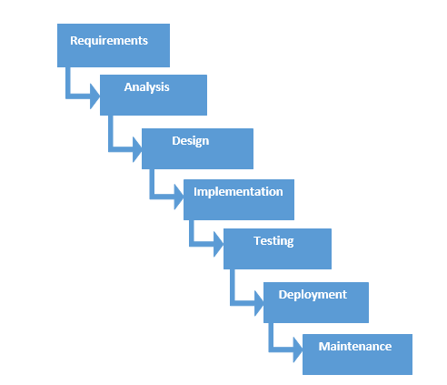



1. Requirements – Sorting out what was needed to make a successful interface

2. Analyzing – Determining how the software will run in the end

3. Design – The process of designing the basic outline of the code before implementing it

4. Coding/Implementation – The actual coding process; building the body of the software

5. Testing – Running the code to determine its functionality

6. Deployment– Displaying the finished product: running it effectively

7. Maintenance – Ensuring that the software will effectively work with time to come

**2.1.4 Challenges**

* Collect all the necessary required information such as
* Applicant details and organization details.
* Implementing the system according to the coding standards.
* Hard adaptability for programming languages.
* Finding organizations with job vacancies.
* Designing a simple and clear user-friendly interface.
* Completing the project within the given deadline.

**2.2 Literature survey**

We have identified the demand of such platforms and we carefully studied such similar platforms and websites. We have kept frequent and proper documentation and updates on our project such that it could be useful in providing insight to others who wish to know the basic breakdown of our project.

**CHAPTER 3 - Design of solution**

**3.1 System Flow**

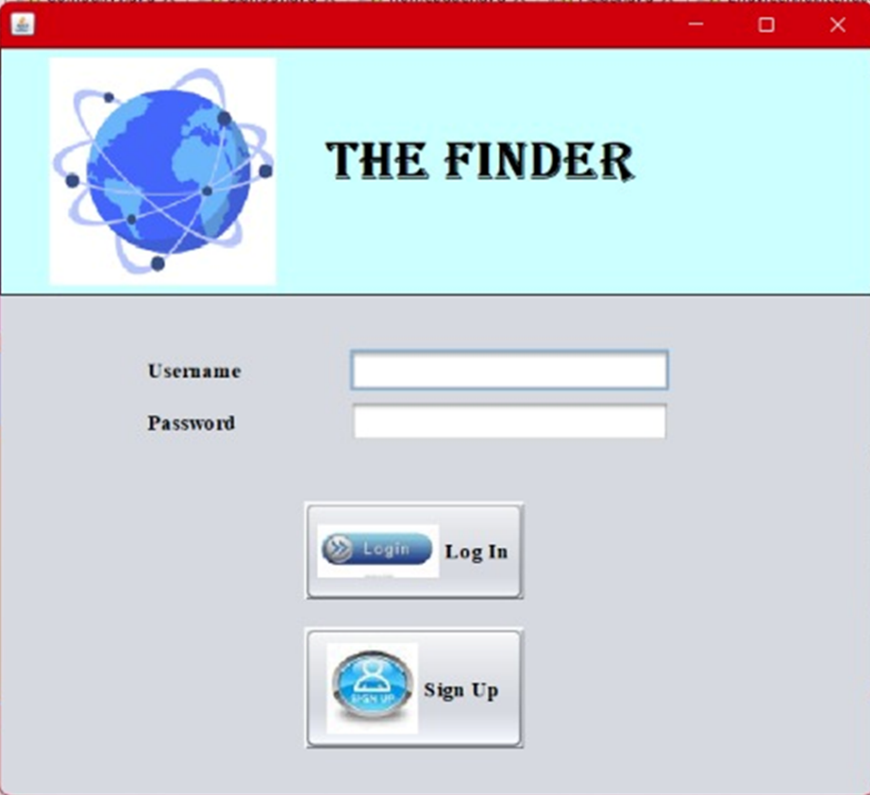

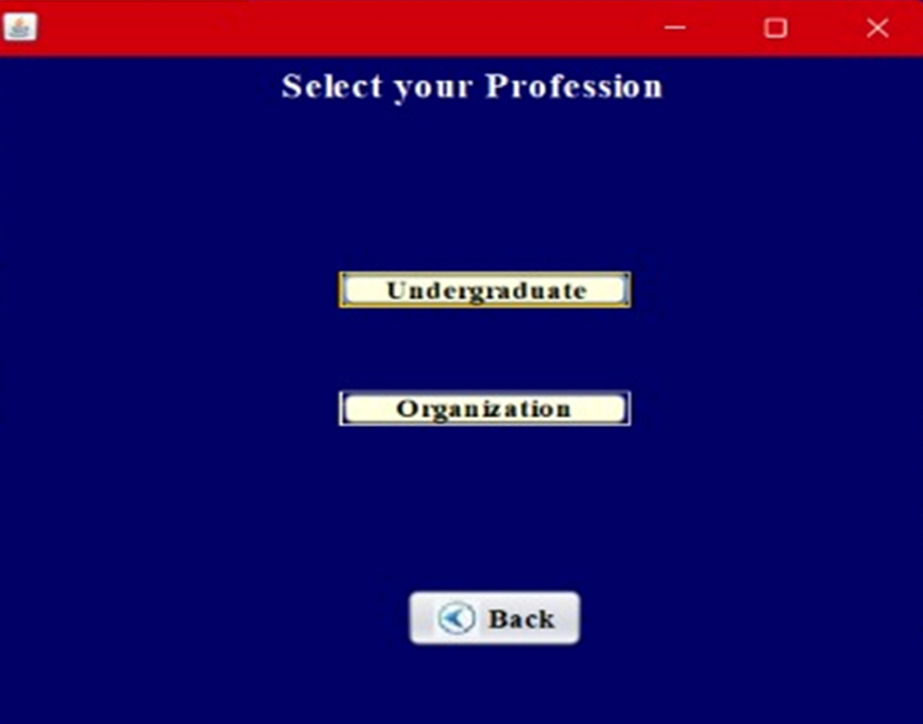

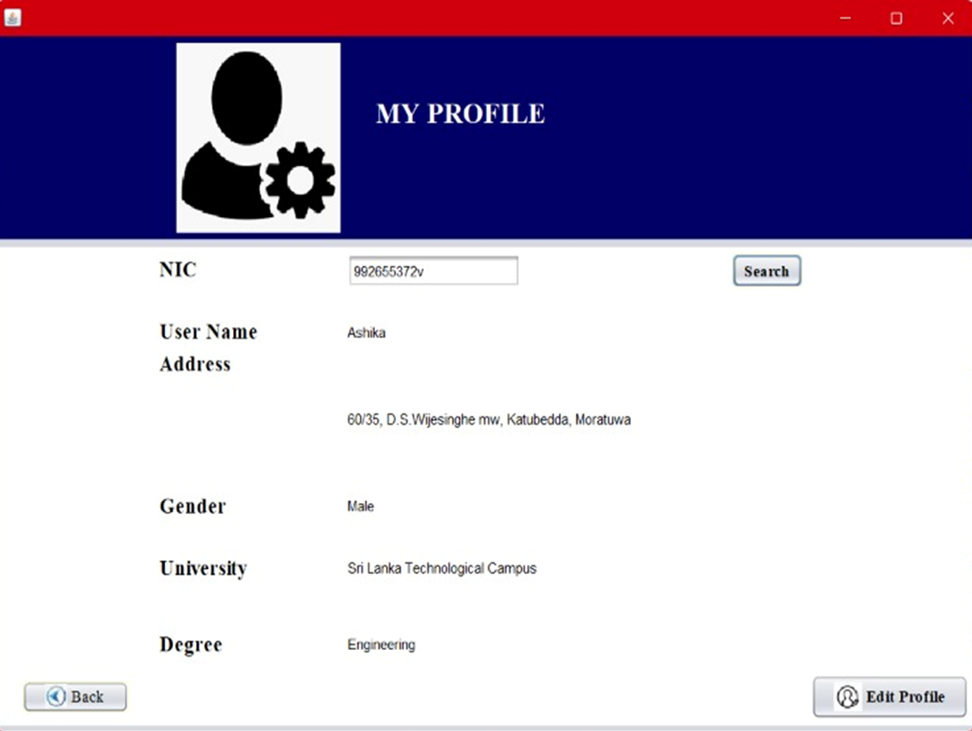



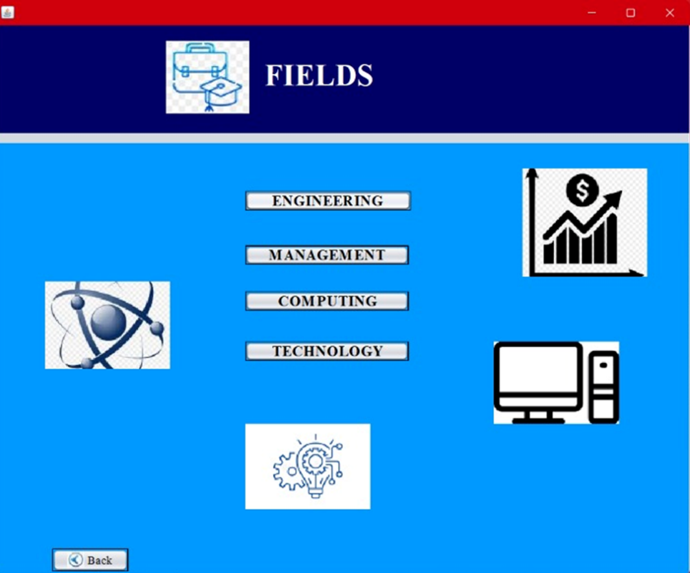



**3.1.1 Demonstrate Further**

* In this system, the job seekers who are willing to know about job vacancies through our system, we provide our email address to inform the admin. Then we will post the advertisement relevant to their field through the email addresses.
* But we hope to develop this system further to post job advertisements in a portal under each relevant job field. This makes it easier to find better job vacancies through the system.
* Also, we hope to add another side which is A/L classes, seminars, and other important posts relevant to A/L streams. Any tutors can post about classes and students can inform about them.

**3.2 The Architecture**

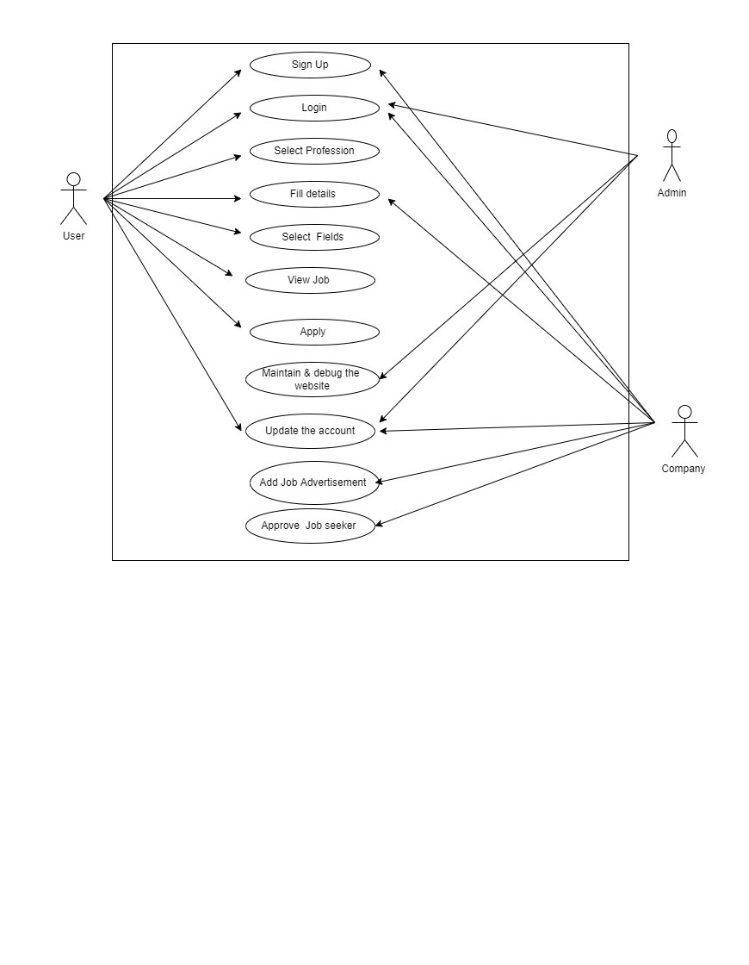**3.2.1 Use Case Diagram**

**3.2.2 Sequence Diagram**

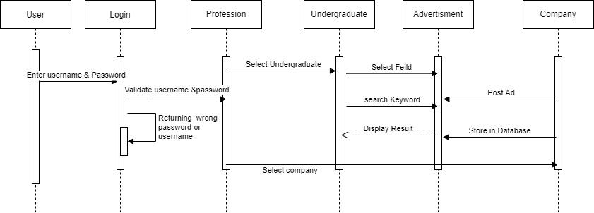

**3.2.3 Activity Diagram**

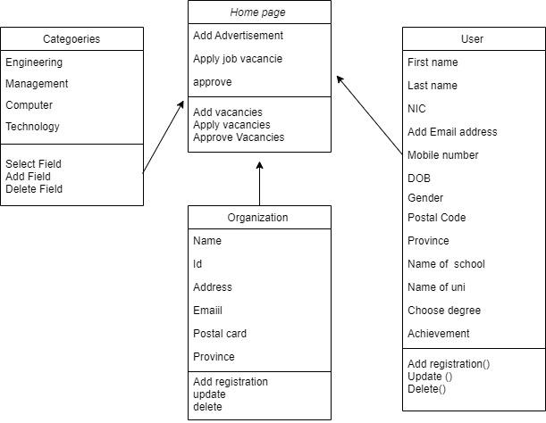

**3.2.4 Conceptual Architecture**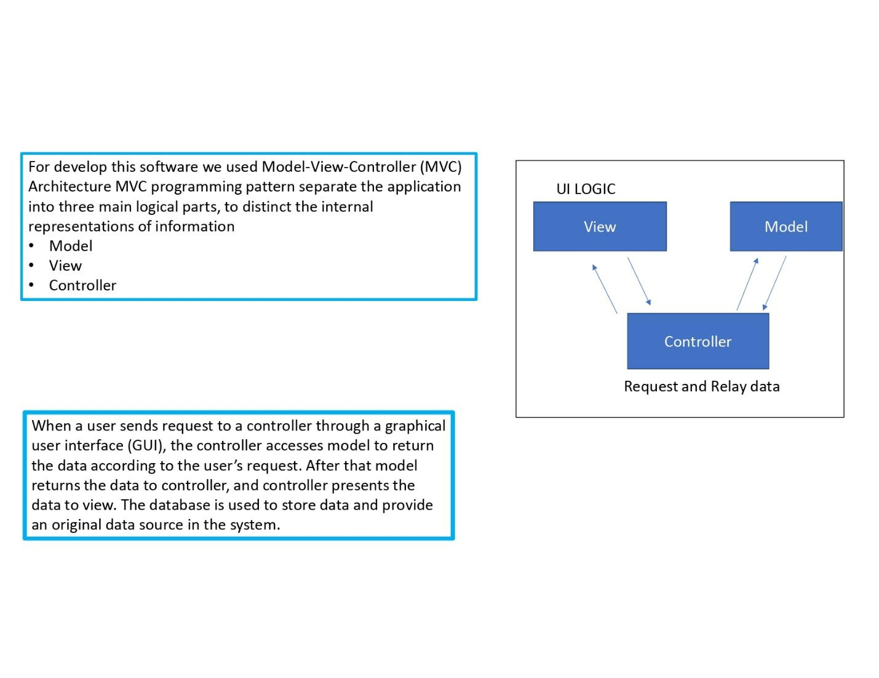

**3.2.5 Advantages of the Architecture**

* Applying online is often easier.
* Better accuracy
* Lack of personal contact.
* Being able to easily find job vacancies.
* Institutions can easily display their job advertisements through this portal.
* Job seekers can easily find a vacancy based on their preference.
* Applicants can apply through this website and the institutions can approve or reject these applications.

**3.2.6 Disadvantage of the Architecture**

* Discriminates against applicants with no computer access.
* Bugs and data crashes.
* Security issues

**3.3 CHARTS**

**3.3.1 Gantt Chart**

**3.3.2 Milestone Chart**

|  |  |  |  |  |  |  |  |  |  |
| --- | --- | --- | --- | --- | --- | --- | --- | --- | --- |
|  | **Oct 8-24** | **Oct 25-31** | **Nov 1-7** | **Nov 8-14** | **Nov 15-21** | **Nov 22-28** | **Dec 1-5** | **Dec 6-12** | **Dec 4-7** |
| **Research** |  |  |  |  |  |  |  |  |  |
| **Practice** |  |  |  |  |  |  |  |  |  |
| **Planning** |  |  |  |  |  |  |  |  |  |
| **Analysis** |  |  |  |  |  |  |  |  |  |
| **Designing** |  |  |  |  |  |  |  |  |  |
| **Development** |  |  |  |  |  |  |  |  |  |
| **Testing** |  |  |  |  |  |  |  |  |  |
| **Implementation** |  |  |  |  |  |  |  |  |  |

**CHAPTER 4 - DISCUSSION**

**4.1 Difficulties arisen**

* Lack of knowledge on how to develop the software.

It contains a lack of programming knowledge and the idea of software developing concepts too. We had spent a long time searching the database through XAMPP because there were many errors.

* Due to the pandemic, there were many communications problems.

Due to the covid epidemic, team members were unable to join the discussion on the project, and the discussion was conducted via Zoom technology

* Gathering the proper and relevant information regarding the requirements.
* Developing the system according to the required coding standards.
* Automating the whole process using the software.
* Completing the task according to the given time frame.

We had not learned about this, so we had to study about it from the beginning. So, there was not enough time to complete the project. It took a lot of hard work to complete the study project in a short amount of time.

* Most importantly, developing the software according to the pre-defined user-friendly requirement

This software can be easily used by any person without any hassle. Finding a vacancy easily without wasting labor, time and money looking for a job.

**4.2 Project Plan**

|  |  |  |
| --- | --- | --- |
| **Theme** | **Epic Stories** | **Backlog items** |
| Job seeker website | Responsibility of user | * Users want to access the website according to their type of user. i.e., Admin, Employer, and job seeker. * As the admin, they are responsible for smooth functionality of the front and back end of the website. * As Employer, they must publish available job openings and this option is only accessed by the employer. * As job seekers, they must follow all the instructions provided by the employer before applying for any opportunities. |
|  | Responsibility of system | * System should store all the information provided by both employers and job seekers. * System should be able to add, update and delete data as per requirement of user type. * System should show relevant output for relevant input by users. * System should store user data without any security threats and should be available anytime when it is needed. |

|  |  |  |  |  |  |  |  |  |  |  |
| --- | --- | --- | --- | --- | --- | --- | --- | --- | --- | --- |
| Work Allocation | Team member name | ID | Week1 | Week2 | Week3 | Week4 | Week5 | Week6 | Week7 | Week8 |
| Project Conception | Tanuli  Ashika  Ahemad  Vishal  Dinithi  Raviprabha  Yohan  Osanda  Chapa  Bhagi | AA1475  AA1373  AA1505  AA1494  AA1312  AA1359  AA1400  AA1431  AA1493  AA1609 |  |  |  |  |  |  |  |  |
| Suggesting ideas about the GUI |  |  |  |  |  |  |  |  |
| Reviewing ideas |  |  |  |  |  |  |  |  |
| Finalizing ideas and drawing basic sketches |  |  |  |  |  |  |  |  |
| Documentation |  |  |  |  |  |  |  |  |  |  |
| Project proposal | Tanuli  Ashika  Ahemad  Vishal  Dinithi  Raviprabha  Yohan  Osanda  Chapa  Bhagi |  |  |  |  |  |  |  |  |  |
| Designing UML diagram | Vishal  Dinithi |  |  |  |  |  |  |  |  |  |
| Project presentation | Dinithi  Vishal |  |  |  |  |  |  |  |  |  |
| Project report | Dinithi  Vishal  Ahemad  Bhagi |  |  |  |  |  |  |  |  |  |
| Initiation |  |  |  |  |  |  |  |  |  |  |
| Getting a list of items that needed to be add to the system | Yohan  Chapa |  |  |  |  |  |  |  |  |  |
| Designing the graphical user interface | Osanda  Ashika  Tanuli |  |  |  |  |  |  |  |  |  |
| Programming | Osanda  Ashika |  |  |  |  |  |  |  |  |  |
| Programming | Ravipraba  Tanuli |  |  |  |  |  |  |  |  |  |
| Adding every item in the database to the software | Osanda  Tanuli |  |  |  |  |  |  |  |  |  |
| Testing and debugging | Tanuli  Ashika  Osanda |  |  |  |  |  |  |  |  |  |
| Testing and debugging | Vishal  Dinithi  Raviprabha |  |  |  |  |  |  |  |  |  |
| Testing and debugging | Yohan  Chapa  Bhagi |  |  |  |  |  |  |  |  |  |
| Testing and debugging | Ahamed  Bhagi |  |  |  |  |  |  |  |  |  |

****